Exploring the function of oncogene ERBB2 by CRISPR CAS technology
by
Abdullah Al Mahmud
MSc Biotechnology with Data Analytics
University of Bedfordshire

Abstract: Cancer is a genetic disease that results from genetic abnormalities affecting normal cellular activities such as division, growth, and death. Different types of tumour suppressor gene and oncogenes are responsible for cancer development. ERBB2, also referred as HER2 (Human Epidermal Growth Factor Receptor 2), is one of the most important ones. HER2 is a receptor tyrosine kinase involved in signalling that regulates cellular growth and survival through pathways such as PI3K/AKT/mTOR and RAS/RAF/MEK/ERK. Dysfunction or mutations of HER2, most frequently linked to overexpression, cause overexpression of this gene, leading to aggressive breast cancer. HER2 is also implicated in ovarian, bladder, gastric cancer, and other cancers.
This study uses CRISPR-Cas9, a precise gene editing tool, to understand the function of HER2 in cancer. CRISPR-Cas9 enables targeted knockout and overexpression of HER2, aiding in understanding HER2’s mechanism of action. The functional assays monitor the effects of HER2 variations on cell growth, survival, and signalling pathways. CRISPR screens are employed to identify genes and pathways related to HER2, helping to find potential targets for therapy. Additionally, creating animal models with specific HER2 mutations enables analysing the effectiveness of novel anticancer treatments in vivo.
This study demonstrates how CRISPR technology can revolutionaries the understanding of the mechanisms that underpin the function of HER2 in cancer. The outcomes may help in the creation of new strategies that can counteract the mechanisms of resistance to current HER2 directed therapies and, consequently, enhance the outcomes for patients suffering from HER2 positive cancers.
Introduction: Cancer develops when cells obtain the capacity to substitute the highly controlled genetic and epigenetic programs that ordinarily oversee proliferation, differentiation, metabolic homeostasis and programmed cell death. These programs are engineered by complex networks of signalling receptors, transcription factors, chromatin remodels and tumour-suppressive checkpoints. These networks can be destabilised by mutations, rearrangements of the chromosomes, amplification of DNA, and deregulation of the epigenetics, resulting in the typical oncogenic phenotypes of prolonged proliferative signalling, growth suppressor/apoptotic location resistance, and metabolic reprogramming [1]. ERBB2 (HER2) is one of the numerous oncogenic drivers that have been identified as part of these processes, and it has emerged as one of the most clinically relevant oncogenic drivers especially in solid tumours where amplified HER2 signalling fosters aggressive tumour biology [2].
HER2 is one of the ERBB family of receptors tyrosine kinases (along with EGFR, HER3 and HER4). The members all possess a conserved domain architecture, which is an extracellular ligand-binding module, a single-pass transmembrane segment, and a cytoplasmic kinase domain. It is remarkable that HER2 is a structurally unusual protein: in reality, it does not have a defined ligand but naturally exists in an open conformation which has been primed to form dimers. As such, HER2 overexpression or mutation leads to steady homo- or heterodimer formation, in particular, HER2–HER3, that constitutively, ligand-independently activates downstream oncogenic signalling [3]. This signalling cascade transmits through a variety of major pathways PI3K/AKT, RAS/RAF/ MEK/ERK (MAPK), JAK/STAT, and SRC/FAK that promote proliferation, survival, angiogenesis, metabolic plasticity, apoptotic resistance and epithelial-mesenchymal transition (EMT) [4].
HER2 amplification also takes place in breast cancer clinically (up to 30% of breast cancer cases) in gastroesophageal, colorectal, lung, ovarian, uterine, and bladder tumours, as well as in gastric tumours. The changes have a significant impact on tumour behaviour, prognosis, and therapeutic decision-making [5]. HER2+ cancers are often marked by increased tumour grade, increased metastatic capability, metabolic plasticity (through AKT/mTOR signalling), and resistance to hormone/cytotoxic therapy regimens. The key role of HER2 in tumour biology has made HER2 a major focus of precision medicine.
The HER2-guided therapy has transformed the clinical oncology in the last twenty years. Several groups of therapeutics exist now:
• Monoclonal antibodies (trastuzumab, pertuzumab) that hinder dimerization and induce antibody dependent cell mediated cytotoxicity.
• Antibody-drug conjugates (T−DM1, trastuzumab deruxtecan) which carry cytotoxic drugs straight to the HER2-expressing cells.
• ATP binding tyrosine kinase (lapatinib, neratinib, tucatinib) inhibitors which block the activity of HER2 kinase.
These treatments have significantly enhanced the survival of HER2-positive breast and gastric cancers [6]. However, regardless of these developments, resistance, both primary and acquired is a significant clinical challenge. The tumours bypass HER2 inhibition by a myriad of mechanisms which includes:
• Truncated HER2 isoforms like p95HER2 which do not have the trastuzumab binding site are expressed.
• PI3KCA-activating mutations and PTEN loss, which reinstates downstream signalling, although blocked by the upstream.
• Bypass receptor tyrosine kinases (EGFR, IGF1R, MET) upregulation or activation that reinstates MAPK or PI3K activity.
• Modifications in tumour microenvironment, e.g. cytokine-mediated JAK/STAT activation.
• The plasticity of phenotype, EMT, and stem-cell like transitions that reduce drug sensitivity [7].
The analysis of these mechanisms of resistance requires accurate tools that can be used to modify genes, signalling networks and chromatin states on fine scales. CRISPR-Cas9 gene-editing system has become the leading technology of functional cancer genomics with unprecedented accuracy, scalability, and flexibility. CRISPR supports clean gene knockouts, point mutations, epitope tags insertion, gene activation (CRISPRa), gene repression (CRISPRi), and scale perturbation screens [8]. As compared to RNAi, CRISPR produces permanent, stable changes with low off-target transcriptional compensation, thus allowing more reliable mapping of genetic dependencies in models of cancer [9].
In HER2 studies, CRISPR has led to the path of mechanistic and translational understanding. Synthetic-lethal interactions of ERBB2 revealed by genome-wide CRISPR loss-of-function screens include regulators of HER2-HER3 dimerization, genes involved in lipid-metabolism that are important to HER2 membrane localisation, and PI3K-pathway components that determine sensitivity to HER2 inhibitors [10]. CRISPR knock-in models have been utilized to question clinical-observed HER2 mutations (e.g., 755S, 777L, S310F), demonstrating the effects of these mutations on receptor structure, kinase signalling and treatment. Knockout of HER3, PI3K subunits, and mTOR regulators and adaptor proteins like GRB2 or SHC1 using CRISPR has clarified the role of certain nodes in HER2 signalling networks in proliferation, metabolic rewiring, therapy resistance, and metastatic potential.
Furthermore, CRISPR-based solutions can now allow:
• Simultaneous interrogation of full signalling pathways, allowing the re-wiring of pathways in HER2-activated circumstances.
• Whole-genome mapping of drug-gene interactions, which discover which genes have been lost in tumours making them more sensitive to the action of HER2 inhibitors.
• Epigenetic CRISPR technologies based on modulation of enhancers controlling ERBB2.
• Single-cell CRISPR screens, discovering gene networks that regulate heterogeneity and resistance trajectories.
Base editing and prime editing methods provide an opportunity to introduce finer clinical mutations with a high level of accuracy, therefore, making it possible to produce patient-engineered variants in the experimental settings. When combined with high-throughput proteomic profiling, phospho-signalling, metabolic and drug-response comparison, researchers can map HER2 reorganization of intracellular signalling networks, mechanisms of therapeutic resistance, and potential molecular weaknesses that, when targeted, could be exploited therapeutically. All in all, the CRISPR technology in ERBB2 tumoral biology creates a powerful system of revealing the necessary co-dependencies, mapping the resistance mechanisms, and creating new therapeutic options. The richness of mechanistic understanding based on these studies is invaluable to the idea of the next-generation HER2-targeted approaches as well as to the overcoming of clinical resistance.
The combination of CRISPR perturbation with proteomics, phospho-signalling maps, metabolic profiling and drug-response experiments can help researchers to uncover how HER2 rewires intracellular networks, how resistance develops, and what vulnerabilities can be therapeutically exploited.
Altogether, CRISPR usage of ERBB2 tumour biology gives a powerful platform towards determining vital co-dependencies, mapping out-resistance mechanisms, and finding new therapeutic markers. Such level of mechanistic understanding is essential to the advancement of the next generation HER2-targeted framework and the overcoming of clinical resistance.
Materials & Methods:
Wet Lab
- Oligo Phosphorylation and Annealing
The first step in the workflow was preparing the reaction mix for phosphorylation and annealing of the ERBB2 oligos. Using a low-volume pipette tip, # Oligo 1 (ERBB2 F1) and # Oligo 2 (ERBB2 R1) were transferred into a sterile microcentrifuge tube. To create the correct reaction environment, 10x T4 Ligase Buffer was added, followed by nuclease-free water (ddH2O). Finally, T4 Polynucleotide Kinase (T4 PNK) was added, bringing the total reaction volume to 10uL.
The reaction mixture was incubated in a thermocycler at 37°C for 30 minutes to allow efficient phosphorylation of both oligos. After phosphorylation, the temperature was raised to 95°C for 5 minutes to denature the strands and prevent premature hybridisation. The thermocycler then cooled the reaction to 25°C at a controlled rate of 5°C per minute, allowing the complementary oligos to anneal gradually.
At the end of this process, the phosphorylated and annealed oligos were ready for use in the subsequent steps of the experiment.
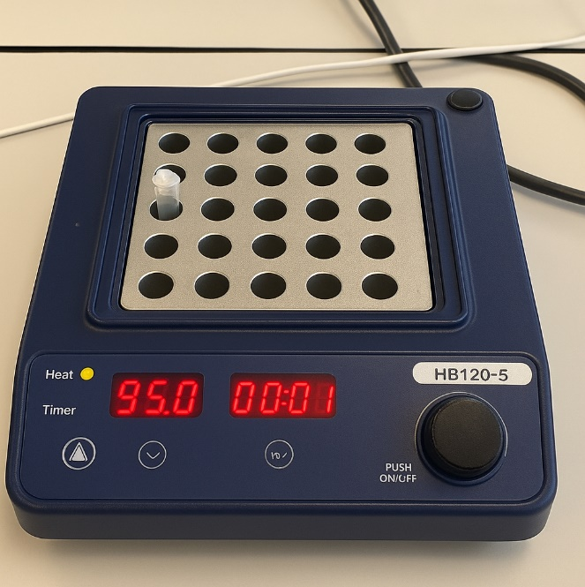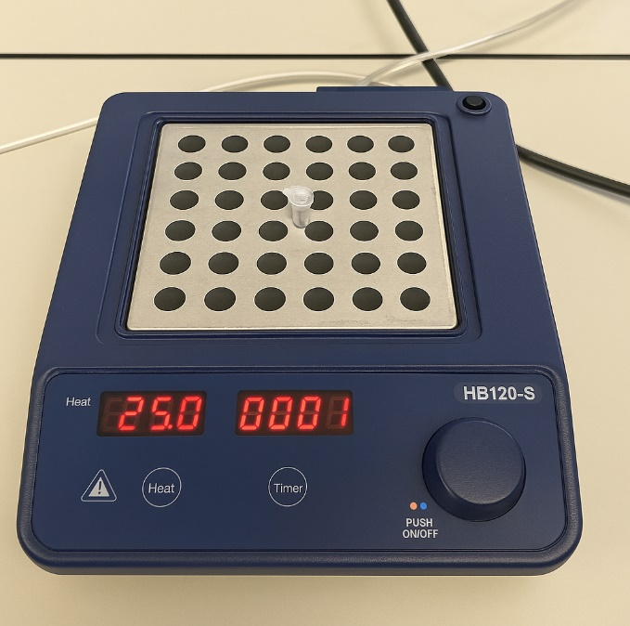
Figure: Heat block incubation at different temperature 95 °C & 25 °C) during ERBB2 oligo denaturation.
- BbsI Plasmid Digestion and Backbone Preparation:
As the oligonucleotides are also being prepared, the CRISPR plasmid backbone PX459, PX458, or other Cas9/nickase derivatives are cut with the type IIS restriction endonuclease BbsI. This plasmid is mixed with FastDigest BbsI, and buffer, and FastAP phosphatase is added to digest 5 ions phosphatases and minimize self-ligation with the backbone. The digestion is accomplished at a temperature of 37°C in half an hour. This is followed by a digestion procedure that is followed by agarose gel electrophoresis in which the product of the digestion is then resolved and the linearized backbone is cleaved with minimum UV exposure.

Figure: CRISPR Plasmid Digestion Setup
- Gel Extraction and purification of Linearized plasmid.
The DNA fragment removed is cleansed through a standard silica column gel extraction kit. The slice of the gel is completely dissolved in the gel solubilizing buffer and centrifuged through the column. The column is again swept by additions of the ethanol-based DNA wash buffer and then eluted in a small amount of pre-warmed elution buffer. A quantification of the purified backbone DNA is kept on ice to be ligated.
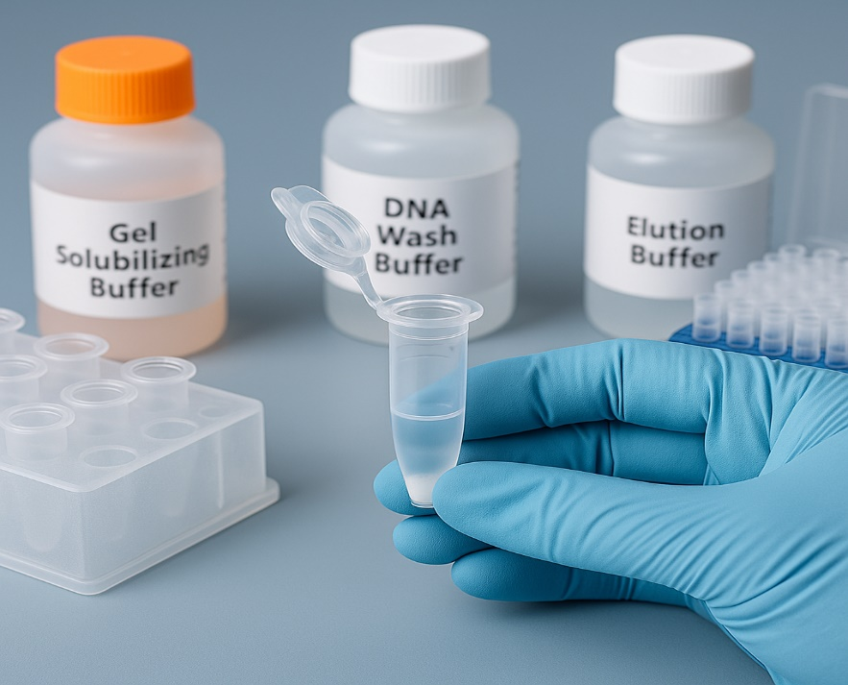

- Annealed Oligos were ligated to PX459.
The Quick Ligase system is used to assemble the ligation reactions. An excess of phosphorylated and annealed oligonucleotide duplex, Quick Ligase buffer, and water is added to the digested backbone with Quick Ligase being the last addition. Preparation of a negative control ligation is made parallel where oligonucleotide duplex is not formed. The reactions are incubated at room temperature both at ten minutes. These ligated samples are used as the input to transformation.
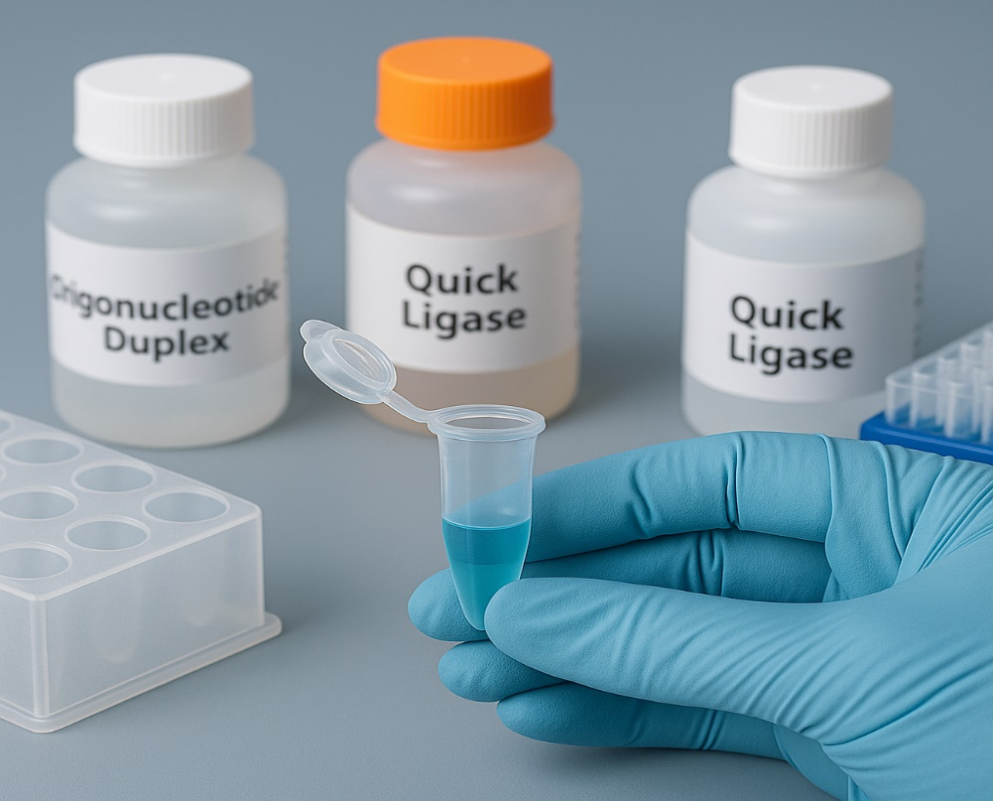
Figure: Assembly of PX459–gRNA Ligation Reaction Using Quick Ligase
- Introduction into Competent E.coli.
Competent E. coli cells (NEB 5- alpha) are placed on ice then gently swirled with a small amount of each ligation reaction. A typical ice incubation phase is followed by a heat shock followed by transfer of the cells in recovery medium. To express antibiotic resistance, cultures are shaken at 37°C. In advance LB agar plates are prepared with the corresponding antibiotic, usually ampicillin in case of PX459-family plasmids. Several plates are streaked; a negative plate (with no plasmid), a positive control of transformation, the ligation control (self-ligated), and the experimental ligation with the guide oligos. Plates are left at 37°C overnight.
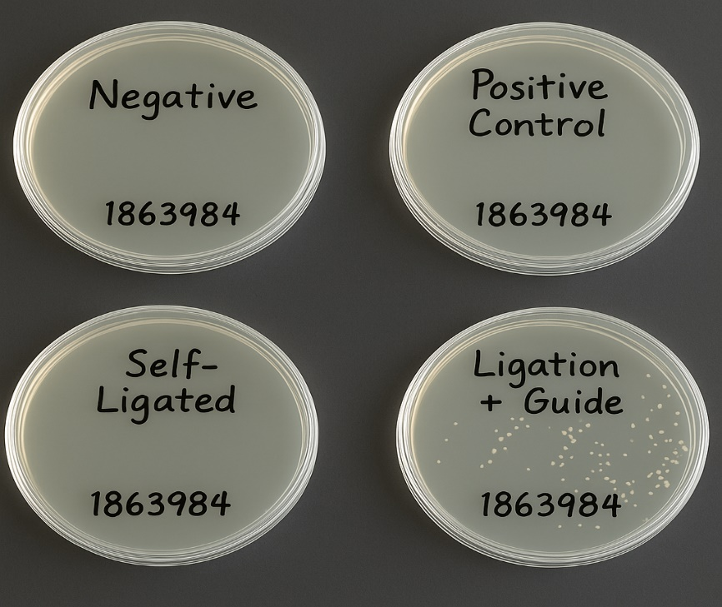
Figure: Colony Formation on Selective LB Agar Following PX459 Ligation Reactions

- Colony Selection, Miniprep, and Verification of the Sequences:
On the next day, single colonies are analyzed. Experimental plate colonies are picked into liquid LB containing antibiotic and incubated overnight at 37°C. These cultures are miniprepped to get plasmid DNA. Confirmation of successful guide insertion is done via colony PCR, diagnostic restriction digestion or Sanger sequencing with flanking primers of the U6-sgRNA site. Clones that have the right sequence of the guide and have a complete plasmid structure are only taken to the downstream work.
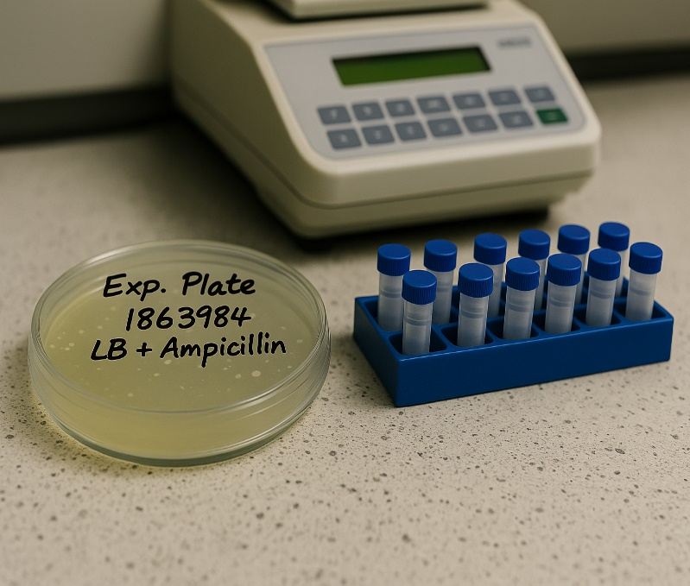
Figure: Experimental Plate (LB + Ampicillin) with Identified Colonies
- CRISPR Plasmid Preparation of CRISPR Plasmid to be transfected:
Clones that are validated are then produced at a greater purity to be transfected. They are mostly done in endotoxin-free midipreps or maxipreps. To verify that DNA concentration and purity meets transfection requirements, Nanodrop or Qubit are used to check them. Any donor templates of HDR (e.g. ssODNs with single-base insertions or deletions) are also completed here, depending on the mutation designs of ERBB2 that have been ready to-date in Benchling.

Figure: DNA Sample Quantification
- Transfection of Mammalian Cells Mammalian Cells:
Mammalian cells are then grown in a 6-well plate in standard growth medium before transfection, which is usually red because of the addition of phenol red, a pH indicator to most cell-culture preparations. During the DNA delivery, the cells are kept at a suitable confluency level to facilitate uptake and expression of components of genome-editing.
A lipid-based transfection reagent is added to purified DNA of PX459 plasmid to enable the development of DNA-lipid complexes. These complexes are then added to the wells of adherent cells in nutrient medium after short incubation. The cells will be then placed back under standard culture conditions and the CRISPR plasmid will allow a demonstration of Cas9 and sgRNA expression.
The population being transfected starts to express the components encoded by the plasmid over the next one to two days. In the case of PX459, a puromycin-resistance cassette is also present such that the successful transfected cells can be selected by the addition of puromycin at a fixed concentration. The culture will then enrich with edited populations only the cells that have absorbed the CRISPR plasmid, being viable under these conditions.

Figure: Mammalian Cell Culture in a 6-Well Plate Prior to Transfection
Conceptual Gene-Editing Design Workflow Using Ensembl and Benchling
1. The ERBB2 Gene Sequence (Ensembl) was retrieved:
The gene-editing protocol, in the first place, requires the specific acquisition of the reference sequence of the ERBB2 gene. In this regard, Ensembl is used as follows: search the human ERBB2 locus by gene ID or a direct search query; explore the structural elements of the gene exons and introns, untranslated regions (UTRs), and isoforms and genomic coordinates; retrieve the full sequence of the genome or individual exons to be targeted; and analyze the conserved domains and known pathogenic variants to identify the regions that are of the most interest to CRISPR targeting. Such care has ensured that later stages of design are based on current, correct genomic data.
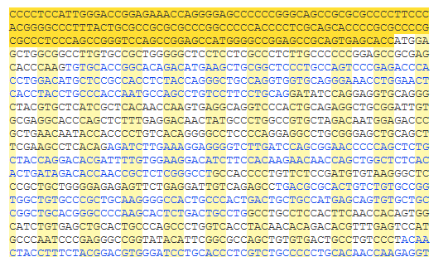
Figure: Partial Sequence of Human ERBB2 gene from ensemble
2. Target Regions for Genome Editing (Ensembl + Benchling) Identification:
Using the visualization tools of Ensembl, functional regions of interest, including oncogenic hotspots, finding domains of indispensable signaling, or mutations reported in the past, are outlined. Benchling will then be used to: obtain the ERBB2 sequence of interest found in Ensembl; annotate exons, coding sequences (CDS) and motifs of interest; and flag prospective CRISPR target windows in which any insertion or deletion would disrupt functional domains. The dual-platform analysis is also needed to provide biological relevance and high-resolution mapping of loci that are targetable.
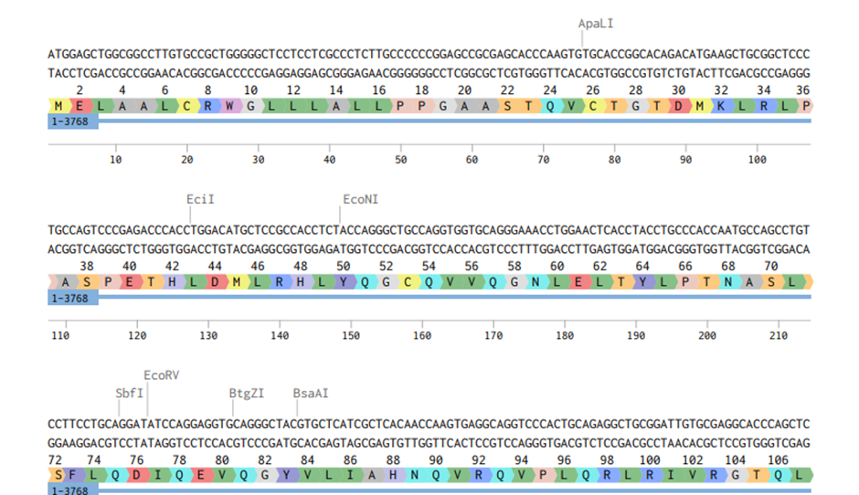
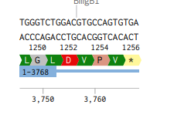
Figure: Partial sequence of ERBB2 from Benchling

3. Guide RNA (gRNA) Candidate Selecting (Benchling):
Benchling provides computational rigor in the selection of candidate guide RNA. At this step, the software searches the imported ERBB2 sequence to identify PAM compatible sites; produces numerous candidates and compares those predicted efficiency and specificity; and offers off-target risk estimates. The researcher can then select guides in areas that are most likely to give loss -of-function phenotypes - e.g. early coding exons or clinically relevant hotspots. It should be mentioned that Benchling is still a theoretical platform; it cannot be implemented at a laboratory level.
The gRNA is-
CACCGCCGGCACAGACATGAAGCTG

4. Benchling In Silico Mutation Planning (Benchling):
After choosing guide RNAs, Benchling models the expected site of cleavage by Cas9, examining the potential surface of cleavage, premature termination, or domain perturbation. In a potential homology-directed repair (HDR) approach, the design tools are used to generate conceptual donor templates, including single-stranded oligodeoxynucleotides (ssODNs) with targeting insertions or deletions. The mutations are visualized at the DNA, codon and amino-acid levels thus explaining their functional implications. The site forecasts the capacity of manipulation of particular nucleotides to modify the structure or activity of ERBB2 protein.
5. Construct Design and Documentation (Benchling):
Benchling is also helpful in: entering the selected gRNA sequences and sites; creating project notes and sequence annotations; creating schematic plasmid maps that indicate the location of sgRNA in PX459 or other CRISPR vectors; and managing version-controlled versions to verify reproducibility and careful record-keeping. In such a way, every design choice can be traced completely.
6. Practicum: Downstream Experimental Work:
Even though Benchling and Ensembl do not perform wet-lab steps, they provide: validated guide sequences; predicted results of editing; annotated genetic maps; design files; and predictions of mutation impact. These deliverables ease the process of moving the computational planning to the empirical validation.

Results: General purpose in this project was to produce guide RNAs that are specifically specific to ERBB2 gene and then transpose these fragments to the PX459 CRISPR/Cas9 expression construct. In this respect we developed two oligonucleotides, namely, ERBB2 F1 and ERBB2 R1, which specificity targets a region of ERBB2 associated to cancer. These oligos were phosphorylated, annealed to form an appropriate duplex, and thus competent to assemble sgRNA: Duplex formation requires special care to assemble a functional sgRNA, which can guide Cas9 to the desired genomic locus.
PX459 backbone was digested with the enzymes with great care to allow ligation at the sgRNA insertion site. The phosphatase treatment was then done to inhibit the background self-ligation and thus only the duly annealed oligos would be able to integrate. Following the annealing of the oligos into the vector, we selected recombinant plasmids that had the sequence of the ERBB2 specific sgRNA. The purification of DNA and the gel electrophoresis tests confirmed that the purification of the DNA was clean and intact and ready to be used in downstream applications.
The recombinant plasmids were inoculated into NEB 5 -alpha competent E. coli. Plate growth LB-ampicillin plates exhibited successful growth: colonies developed on the positive control, self-ligation and oligo-insert plates, but not on the negative control. On that note we picked up the individual colonies, cloned them, prepared the plasmids and made sure that the guides got inserted by standard molecular validation assays.
The validated plasmids were then purified to a high level of purity to be used in cell-based experiments. The endotoxin-reduced DNA preparation method was used to remove any possible contaminants that might affect the cellular assays. The concentration and purity of DNA was measured with spectrophotometric or fluorometric systems (e.g., Nanodrop, Qubit) and ensured that every construct could satisfy the high standards demanded downstream use.

ERBB2 Mutation 1: by deletion of Guanine
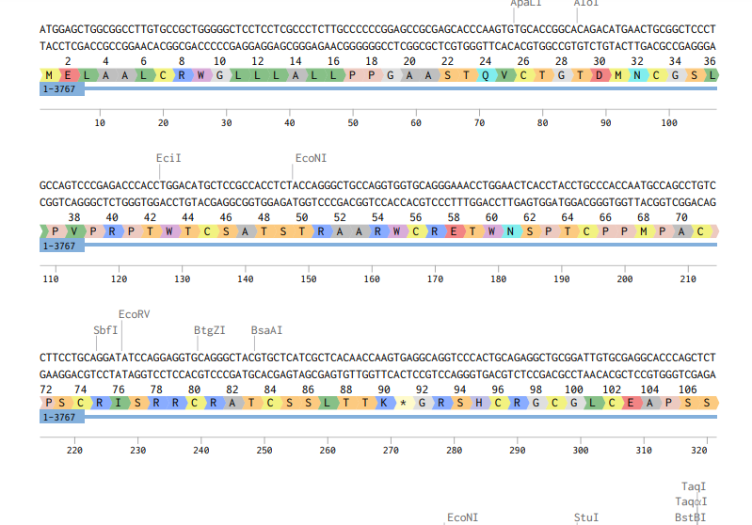

Mutation 2: Deletion of AAG
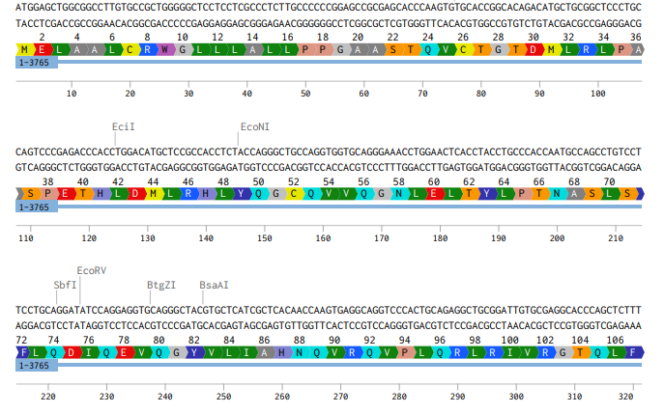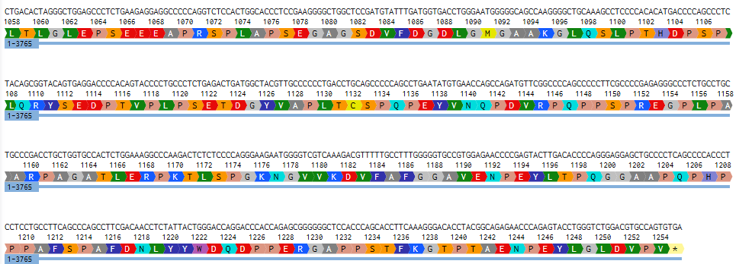

Mutation 3: By addition of ATC

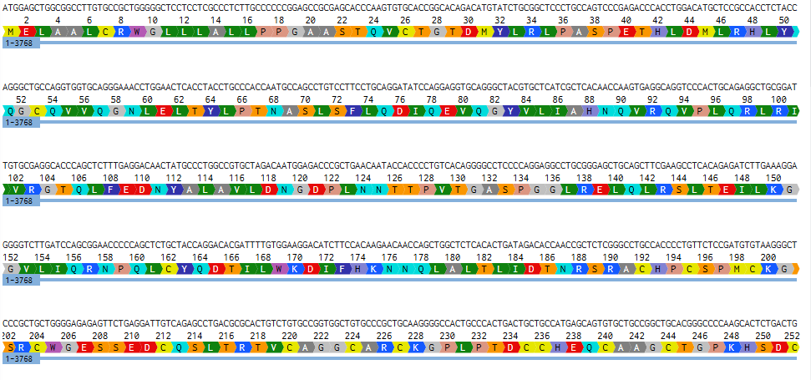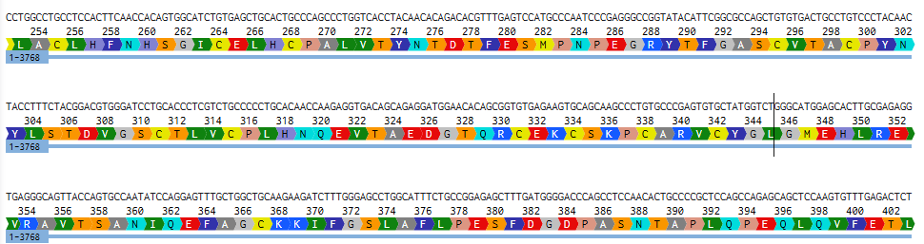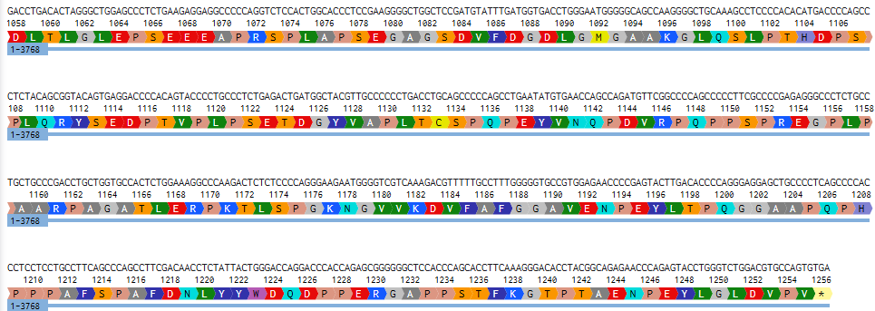
Discussion: In the first mutation the deletion of nucleic acid Guanine (G) here, in the current study has produced an ERBB2 frameshift mutation which results in a truncated HER2 receptor lacking most functional domains. This mutation starts with a shift of the frame at amino acid 32, resulting in a premature stop codon in residue 91. This truncation removes the transmembrane component, the juxta membrane component and the intracellular tyrosine-kinase component- elements that play a crucial role in HER2 mediated oncogenic signalling [11]. Since HER2 is a ligand-independent dimerization partner of other ERBB family members (especially HER3), deletion of these domains interferes with the receptor mediating PI3K/AKT and MAPK activation, two of the most fully understood drivers of HER2-amplified tumour progression [12, 13].
The deletion of lysine at position 32, which is a stability-related residue in the L1 domain of the HER2 extracellular region, is one of the first structural effects of the mutation. This domain is required in creating the dimerization interface of HER2 and HER3. The destabilisation of this stabilising residue disrupts the HER2-HER3 interaction, which is a collaboration that forms potent mitogenic signalling in both breast and gastric cancer [13]. Therefore, not only is the mutation that removes whole downstream domains, but also early structural requirements of heterodimer formation are disrupted.
Functionally, deletion of the kinase domain of HER2 inhibits the ability of the protein to phosphorylate its substrates and pass proliferative messages. The HER2-receptor oncogenesis is mediated by Tyrosine-kinase activity whose deficiency leads to a non-functional HER2 oncogenic receptor that cannot sustain the oncogenic transcriptional programmes [14]. Additionally, owing to the removal of most of the extracellular domain, comprising epitopes bound by trastuzumab (Herceptin) and pertuzumab, tumours with this truncation would intrinsically be resistant to conventional HER2-targeted antibody therapies [14, 16]. This is in line with previous findings that truncated HER2 fragments, called p95HER2 or highly distorted extracellular domains result in a clinical HER2 antibody resistance [15].
In addition to loss of function, truncated ERBB2 variants can have dominant- negative effects. Even non-functional HER2 fragments can bind to other ERBB receptors but cannot transmit a signal, and hence prevent normal ERBB network activity. These maladaptive interactions can provide a further complexity of tumour behaviour and may increase the biological effects of the frameshift mutation [13].
Clinically, this form of mutation is rather hard to identify by protein-based tests like immunohistochemistry (IHC), which depends on the presence of intact extracellular epitopes. Equally, fluorescence in situ hybridisation (FISH) that identifies the amplification of genes but not the sequence-based alterations can miss truncating mutations. Subsequently, it needs next-generation sequencing (NGS) to detect and classify the ERBB2 frameshift variants of the patient tumours precisely [13, 16].
Even though the mutation suppresses HER2 involving signalling, tumours can overcome this loss by engaging other compensatory signalling mechanisms, including EGFR or MET. These other survival pathways can support the cell proliferation as well as lead to therapeutic resistance, highlighting the versatility of HER2-dependent cancers [12]. The rational approach to cancers with non-functional ERBB2 variants has been suggested to be to target downstream pathways (e.g. PI3K, AKT, MEK inhibitors) or co-target compensatory receptor -tyrosine kinases [16].
In general, this frameshift mutation is expected to result in the creation of a non-functional truncated HER2 receptor, the removal of conventional therapeutic targets, and possibly changes the HER2 signalling dynamics due to dominant-negative effects. These results demonstrate the significance of a thorough molecular profiling and justify the necessity of alternative methods of treatment in the cases of the presence of ERBB2 truncating mutations.
Mutations 2 (deletion of AAG) and 3 (insertion of ATC) alter DNA sequence of the early coding region of *ERBB2* with subsequent replacements of the wild-type lysine in position 32 with methionine (M) or tyrosine (Y) respectively. Notably, the replacements do not interrupt the downstream reading frame & known as missense mutation cause two mutations maintain the natural end codon at amino acid 1256 thus producing a full-length HER2 receptor instead of a truncated or loss-of-function protein.
The lysine residue at the position 32 is in the L1 extracellular subdomain and helps to maintain the structure, its substitution with methionine or tyrosine results in the introduction of residues with different biochemical characteristics. Less flexible and hydrophobic methionine and larger aromatic tyrosine could potentially have a subtle effect on the folding and microenvironment of the L1 domain and have the potential to affect the receptor surface stability or dimerization efficiency [17,19]. However, since the receptor is not deleted of any downstream domains (the dimerization interface, the transmembrane helix, and the intracellular tyrosine kinase domain) it is likely that its overall architecture and functional capacity would be fairly preserved.
Full-length HER2 functions as a ligand-independent dimer, which most effectively occurs with HER3 to activate PI3K/AKT and MAPK signalling pathways leading to proliferation in HER2-driven malignancies [20]. Mutations 2 and 3 are expected to retain these oncogenic processes since they do not shorten the length of the receptor. Therefore, they are likely to have mild or hypomorphic effects and change local structural stability and not eliminate HER2 activity.
These strains preserve the extracellular epitopes required in the binding of HER2-targeted therapies like trastuzumab and pertuzumab therapeutically. Although subtle conformational variations can cause changes in binding affinity, it is reported that point mutations in general are not altered sensitivity, unless they disrupt the binding epitope or the kinase domain [21, 22]. In this regard, the tumours with M32 or Y32 variants can still respond to available HER2-targeted monoclonal antibodies or tyrosine-kinase inhibitors.
Although, most variants of the ERBB2 do not carry the amplifications and are often missed by diagnostic methods like the IHC or FISH. Next-generation sequencing (NGS)-based comprehensive genomic interrogation is thus needed to properly classify these substitutions [27]. Knowledge of the biological importance of these N -terminal variants has clinical implications since small extracellular changes can impact dimerization, sensitivity to drugs, or subsequent signalling [25].
Future Researches
The mutations 2 and 3 are valuable resources to scientific and translational studies in the future:

- Computational and Structural Modelling: Even conservative amino-acid modifications have been shown to influence HER2 extracellular stability or domain flexibility using journal evidence [23]. It is possible that, it can help clarify the subtle shift in conformational equilibrium of the L1 domain by prospective modelling, thus affecting dimerization efficiency or receptor mobility.

- Signalling Characterisation:
It has also been demonstrated that single residue changes in ERBB receptors regulate the strength of signalling in the PI3K/AKT or MAPK downstreams [24]. The definition of the effects of these mutations on pathway activation as compared to wild-type HER2 will improve our knowledge of HER2 biology.
- Therapeutic Response Assessment:
Other domains of HER2 point mutations have been revealed to change the sensitivity to the inhibitors and antibodies [25]. Mutations 2 and 3 may explain whether changes at the N-terminus impact:
– trastuzumab binding,
– inhibition by pertuzumab, or
– small-molecule activity of kinase inhibitors.

- Interactions of Compensatory Pathways:
HER2 based tumours often resist inhibition by stimulating other receptors e.g. EGFR, HER3, IGF -1R or MET [26]. Mutations 2 and 3 provide a platform to understand the effects of more limited mutations in the HER2 structure and their dependence on other signalling pathways.

This Training Course aims to develop a system of clinical variant classification by identifying the clinical manifestations and classifying them into distinct categories of periodic clinical diseases.<|human|>Clinical Variant Classification This Training Course expects to create a scheme of clinical variant categorization by describing the clinical signs and grouping them into separate groups of periodic clinical illnesses.
A large number of the variants of the ERBB2 that have been identified during sequencing experiments are not variants of importance. The examination of minor replacements such as M32 and Y32 can be useful in improving the variant classification models thus helping to improve oncology precision [27].

Individualised Development of Treatment.
There is evidence of non-amplified HER2 mutations being useful therapeutic targets [28]. A better understanding of the effect of N-terminal substitutions on the activity of HER2 may inform the design of new therapeutic agents of specific combination regimens.

Conclusion: This initiative provides a strict paradigm of separating the functional implications of the ERBB2 variation by incorporating specific CRISPR mutagenesis with structural and mechanistic explanation. Instead of considering HER2 changes as one-dimensional category, the paper shows that mutations within the same local sequence milieu may radically change biologically. The analogy between a devastating frameshift mutation and two non- truncating missense mutations highlights a major conceptual principle of oncogene biology: whether or not a mutation is pathogenic depends not only on its location, but more importantly on its structure and its ability to alter signalling topology.

The article proves the fact that the early-coding mutations in ERBB2 do not equally impair the functionality of the receptor. The frameshift mutation disrupts the structure of HER2, removing its signalling capability, but the K32M and K32Y mutations do not, leaving the receptor intact in all its length and molecular domains needed to perform an oncogenic role. This opposition underscores the need to start to go beyond dichotomous categorizations as pathogenic or benign and move to mechanically solved variant interpretation, a trend that is being largely prioritized by precision oncology. The obtained variants are thus not only experimental products, but as model alleles to study the propagation of subtle biophysical variation in higher-level signalling networks.
One of the most important conceptual advancements of this project is that the application of CRISPR -based mutagenesis can be applied to recreate clinically observed variants presented under a controlled genetic background to allow the examination of mutation-specific effects in the absence of copy -number variation, co -mutations or microenvironmental heterogeneity. By thus doing so, the effort augers well with a larger trend in cancer genomics: that of moving away banked mutations to banked mutations that are functionalized. The methodology used here is an example of the ways in which genome editing can be used to bridge the long-standing gap between the identification of variants and their biology, particularly in the case of ERBB2, where its numerous variants of the protein are still not characterised in spite of their mounting presence in tumour-sequencing studies.
The translational implication of the study is also on the distinction between truncating and non-truncating versions of ERBB2. In comparison to loss-of-function alleles that can remove therapeutic targets and reestablish signalling dependencies, structurally intact HER2 variants, such as those generated in this study, still have the capacity to affect dimerisation equilibria, ligand-independent activation and drug responsiveness. Based on this, the mutations described in this paper present a basis upon which future studies can map the functional space of HER2 mutations, gain insights into the drug sensitivity/drug resistance mechanisms, and improve the selection criteria of HER2-targeted therapies.
In a broader sense, the project helps in the development of the understanding of HER2 as a modular signalling receptor whose performance can be determined by the combination of extracellular domain stability, transmembrane orientation, and intracellular kinase conformation. The study broadens the conceptual horizons of how the HER2 function can be altered outside of its canonical kinase domain by addressing the aspect of early coding variation, which has been historically little addressed in the literature.
Eventually, this project represents the potential of CRISPR-powered functional genomics as a discovery engine in cancer biology. It offers a scalable approach to systematically interrogating oncogenic variants, creating experimental models of refined study of precision-oncology studies, and developing the mechanistic framework needed to convert genomic approaches into more refined therapeutic models. By so doing, it will proceed to inform the methodological and conceptual frameworks that will be required in future studies to deconvolute the intricate mutational environment surrounding ERBB2 and its involvement in tumour progression.
References:
- Hanahan, D. (2022) ‘Hallmarks of cancer: New dimensions’, Cancer Discovery, 12(1), pp. 31–46.
- Loibl, S. and Gianni, L. (2017) ‘HER2-positive breast cancer’, The Lancet, 389, pp. 2415–2429.
- Hynes, N.E. and MacDonald, G. (2021) ‘ErbB receptors and signalling pathways in cancer’, Current Opinion in Cell Biology, 69, pp. 93–102.
- Mishra, R. et al. (2024) ‘HER2-driven signalling mechanisms’, Nature Reviews Cancer, 24(3), pp. 185–202.
- Wang, J. et al. (2020) ‘Prevalence of HER2 amplification across solid tumours’, JCO Precision Oncology, 4, pp. 1194–1207.
- Modi, S. et al. (2022) ‘Trastuzumab deruxtecan in HER2-positive cancers’, The New England Journal of Medicine, 386, pp. 610–621.
- Rexer, B.N. and Arteaga, C.L. (2015) ‘Resistance to HER2-targeted therapies’, Cold Spring Harbor Perspectives in Medicine, 5, a017337.
- Jinek, M. et al. (2015) ‘CRISPR-Cas9: A versatile genome editing system’, Science, 350, pp. 147–150.
- Meyers, R.M. et al. (2017) ‘Correction of copy-number effects in CRISPR screens’, Nature Genetics, 49, pp. 1779–1784.
- Roper, J. et al. (2019) ‘ERBB2 synthetic-lethal partners identified through CRISPR screening’, Cell Reports, 29, pp. 1151–1166.
- Santhanakrishnan, J. et al. (2024) ‘Structural biology of HER2/ERBB2 dimerization’, Experimental Medicine.
- Sun, Z. et al. (2015) ‘Analysis of different HER2 mutations in breast cancer’, BMC Cancer, 15, p. 50.
- Cheng, X. et al. (2024) ‘A comprehensive review of HER2 in cancer biology and therapeutics’, Genes, 15(7), p. 903.
- Nahta, R. et al. (2006) ‘Mechanisms of trastuzumab resistance’, Oncogene, 25(47), pp. 6553–6564.
- Anido, J. et al. (2006) ‘Biosynthesis of tumorigenic HER2 C-terminal fragments’, The EMBO Journal, 25(22), pp. 5382–5391.
- Chung, A., Kelly, C. and O’Shaughnessy, J. (2013) ‘Current status of anti-HER2 therapies’, Breast Cancer Research, 15, p. 207.
- Xu, J. et al. (2022) ‘Structural insights into HER2 extracellular domain stability and mutation effects’, Journal of Molecular Biology, 434(15), 167503.
- Choi, Y. and Chan, A.P. (2015) ‘PROVEAN: Predicting the functional effect of amino acid substitutions’, Bioinformatics, 31(16), pp. 2745–2747.
- Lee, J. et al. (2020) ‘Functional characterization of ERBB2 point mutations in human cancers’, Cell Reports, 30(13), pp. 4112–4124.
- Yarden, Y. and Sliwkowski, M.X. (2001) ‘Untangling the ErbB signalling network’, Nature Reviews Molecular Cell Biology, 2(2), pp. 127–137.
- Slamon, D. et al. (2011) ‘HER2-targeted therapy in breast cancer’, The New England Journal of Medicine, 365, pp. 1273–1283.
- Greulich, H. et al. (2012) ‘Functional analysis of receptor tyrosine kinase mutations in lung cancer’, Cancer Cell, 21(4), pp. 555–567.
- Kancha, R.K. et al. (2011) ‘Differential sensitivity of ERBB2 kinase domain mutations to HER2 inhibitors’, Cancer Research, 71(11), pp. 3928–3937.
- Bose, R. et al. (2013) ‘Activating HER2 mutations in HER2 gene–amplified breast cancer’, Proceedings of the National Academy of Sciences (PNAS), 110(17), pp. 6734–6739.
- Greulich, H. (2010) ‘The role of HER2 mutations in lung cancer’, Clinical Cancer Research, 16(17), pp. 4425–4433.
- Sergina, N.V. et al. (2007) ‘Escape from HER2 tyrosine kinase inhibitors by activation of the IGF-1R pathway’, Nature, 445, pp. 437–441.
- Drilon, A. et al. (2018) ‘ERBB2 alterations as actionable targets across cancer types’, Nature Reviews Clinical Oncology, 15, pp. 334–348.
- Hanker, A.B. et al. (2019) ‘HER2 mutations in cancer: mechanisms, clinical significance, and therapeutic strategies’, Oncogene, 38(23), pp. 4020–4034.

